Good Day created by: lavashti washington

# Description

Gud Day is a personal pick-me-up for people every-time they open it. This app will simply share a complement, positive message, or even a thank you when no one else may be available to do so..

## How it works

1. The app is built around a constant rotation of phrases, quotes, and compliments that will be displayed to the end-user whenever they open or refresh the app.
2. The app will require the user to completely close the app to prompt a new response.
3. All responses will be randomly chosen and displayed each time the app is opened.

Problem addressing

When you work hard, take care or do for others, and focus the majority of your time to producing things that hold more effect on those around you; it is very easy to forget how admirable the simple good deeds like holding the door for a stranger as you exit a store so they can enter, or just ensuring you make it to work on-time every day to set a good example for the other staff members really are. I try remind myself that the work I do and the positive energy that I put forth in the world is worth doing even when no one else will recognize that work. I do this so I don’t overlook my everyday approach to being a good person. We all should be reminded that by just simply trying to be a good person is worthy of recognition. The GUD DAY app is there to do just that!

# Platform

Native (adroid) platform

# front/back end support

Front-end – xml coding, android studio

Back-end – SQL database

# functionality

* Simple user friendly setup with a warming and positive
* Opens to a home page with a tabbed menu for service info, user login, and other features.
* Includes a search button to open the search form for car service.
* Include push notifications feature for service reminders and updates
* Include a customer feedback section

# Design

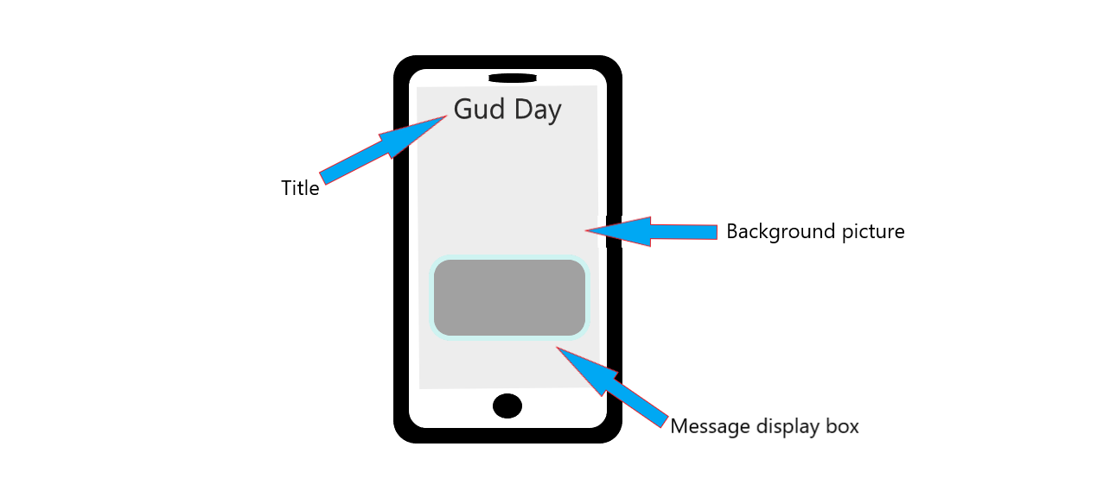

# GIThub readme

https://github.com/washingl/App-Project/tree/main#readme